**Installation guide**

This installation guide has been done on Windows 64-bit machine, please check your machine first.

Installation Requirements: Admin rights

1. Copy all the Softwares into your local machine
2. Install Pycharm by double clicking on file pycharm-community-2018.2.2.exe

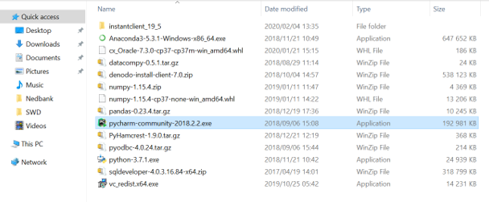

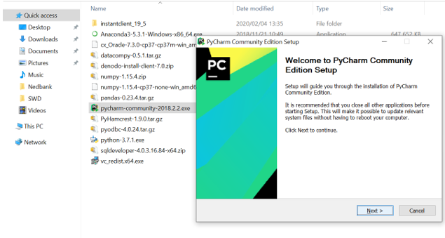

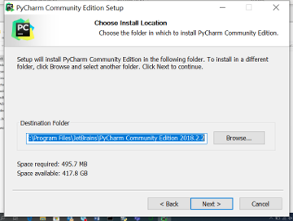

Select **Next**

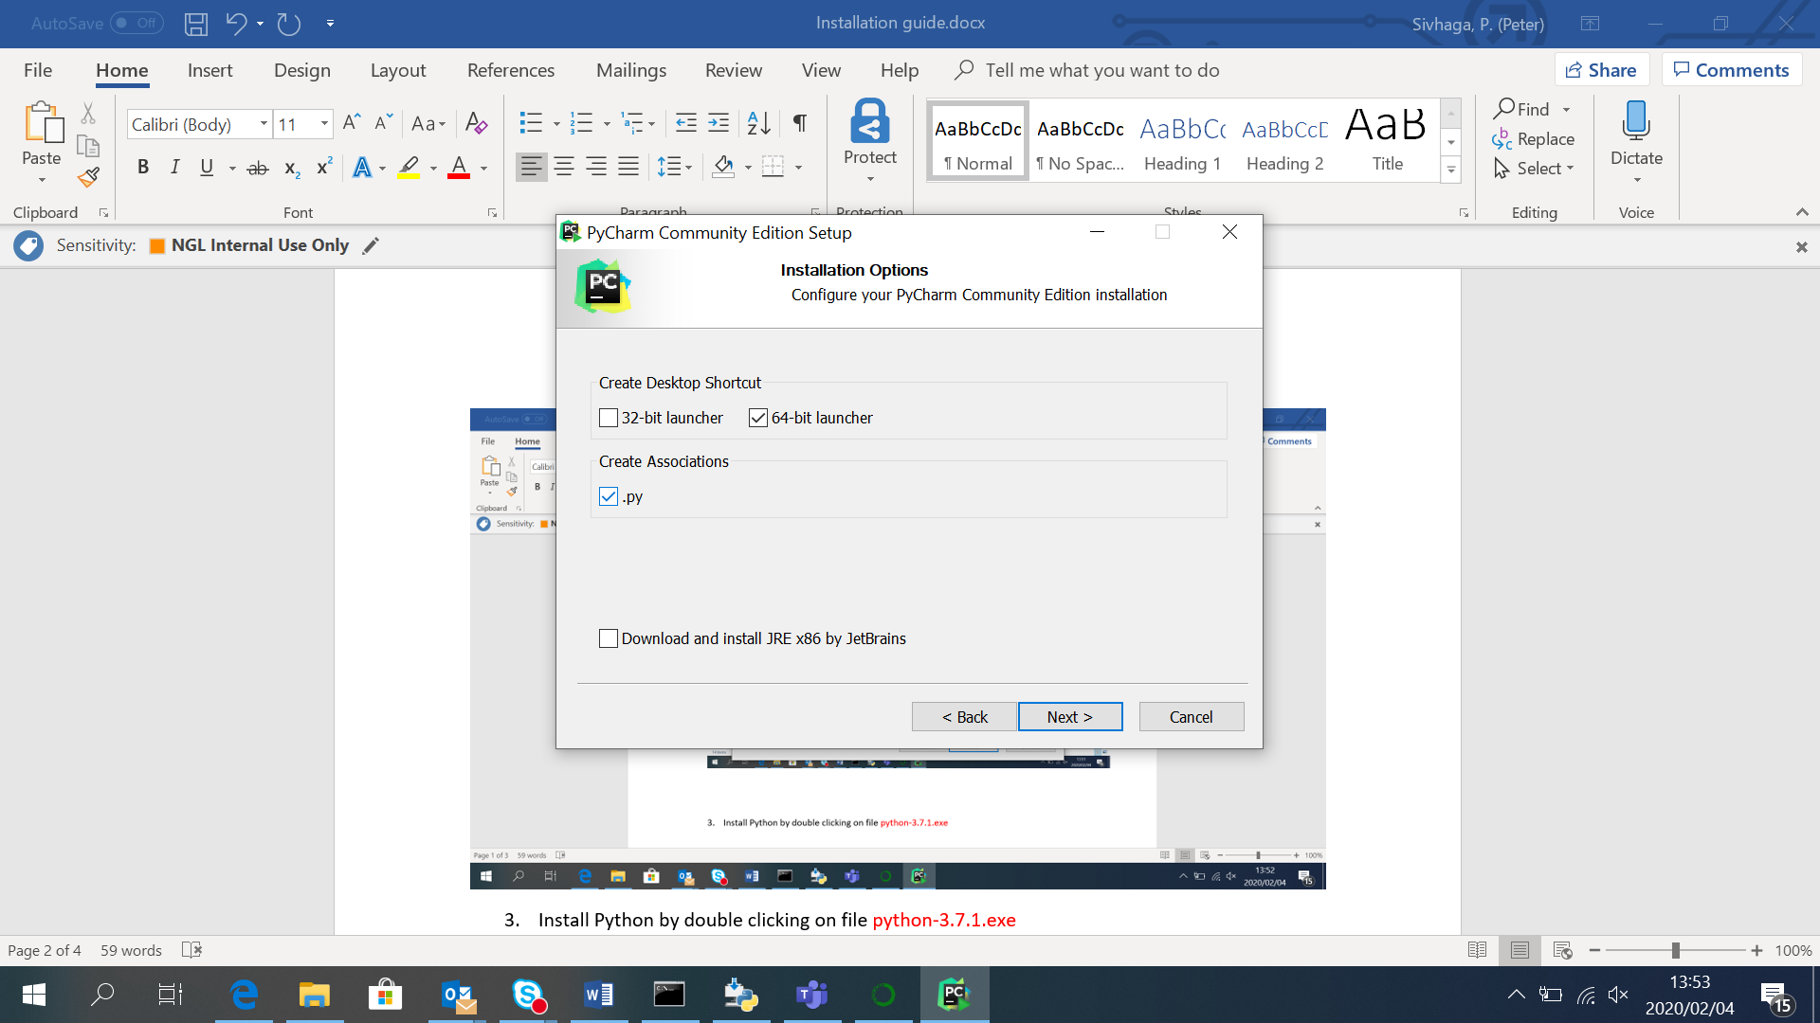

Select **64-bit launcher** and **.py** below and click next

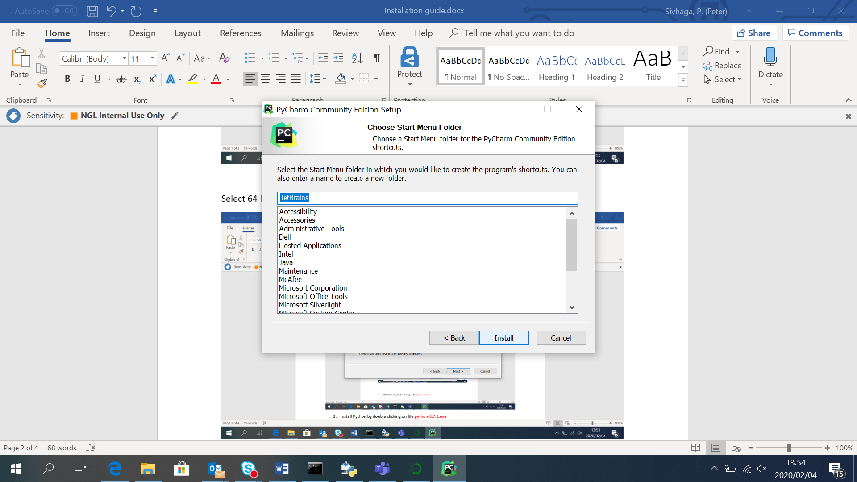

Click **Install** and wait until installation is complete

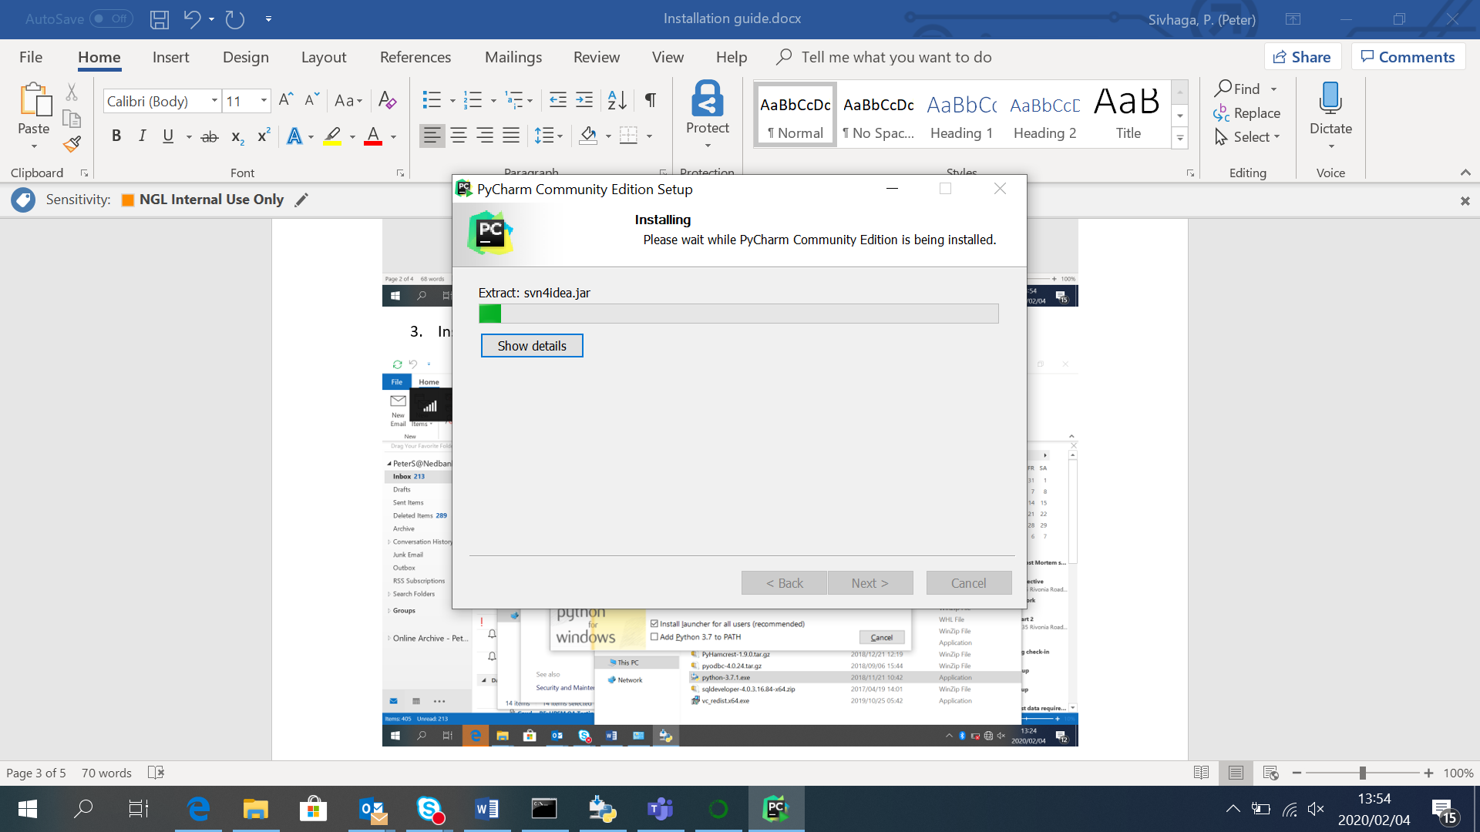

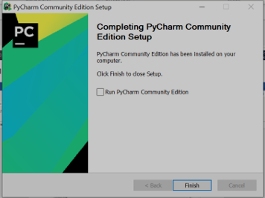

Click on **Finish**

1. Install Python by double clicking on file python-3.7.1.exe

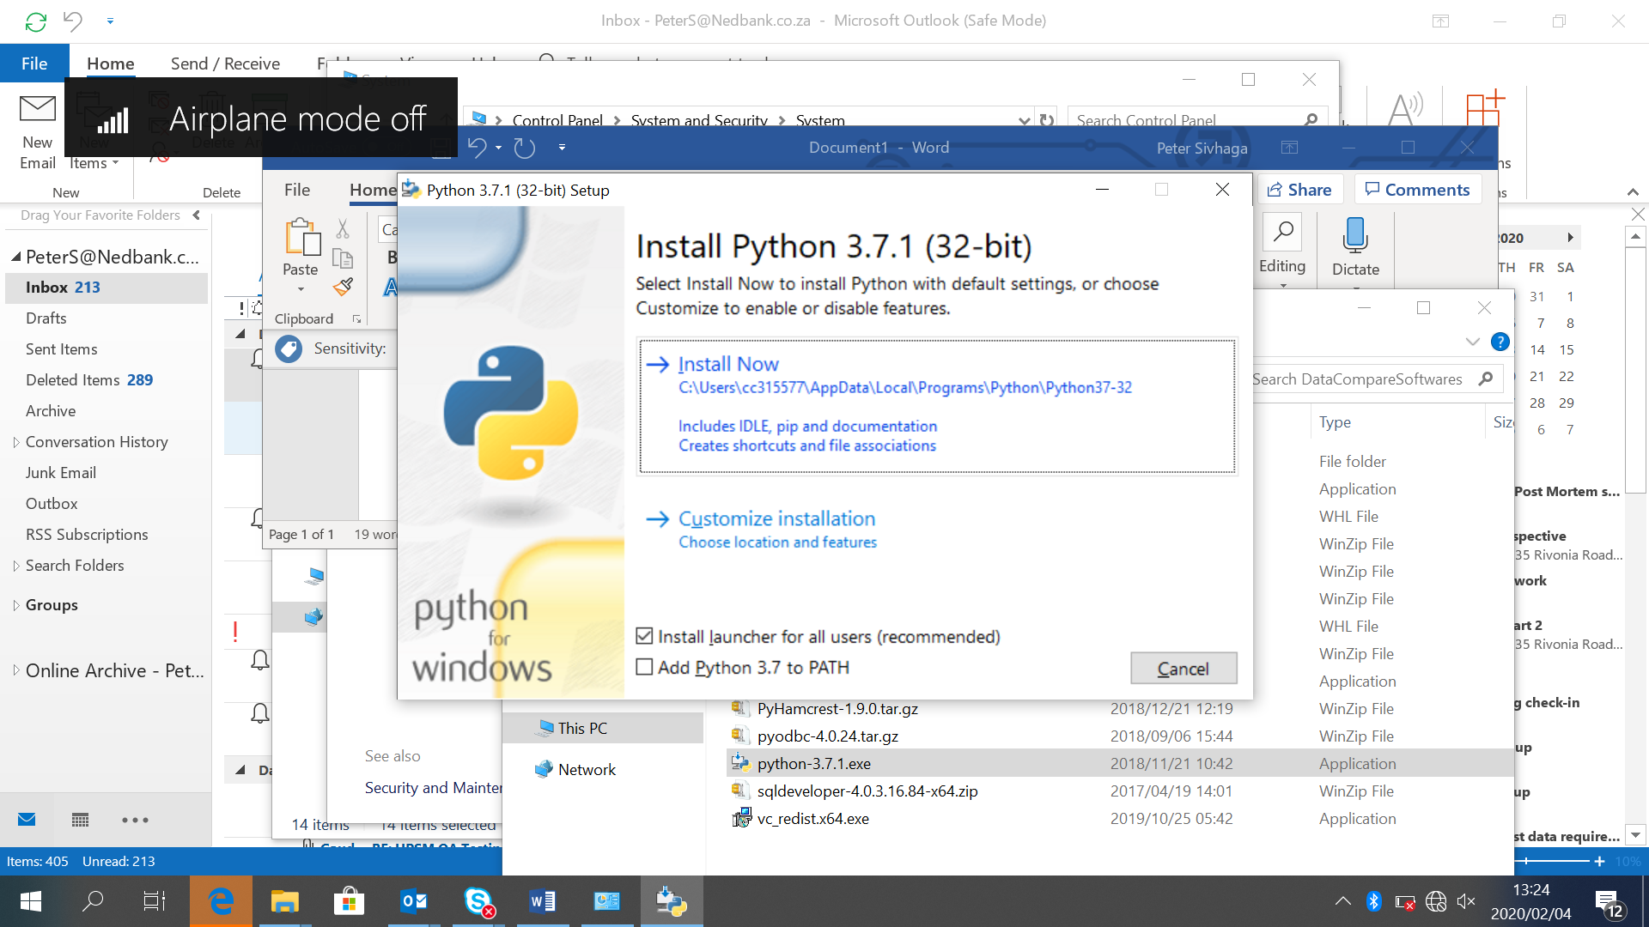

1. Tick on both checkboxes **Install launcher for all users(recommended)** and **Add Python 3.7 to PATH**
2. Select on **Install Now** and wait until successfully installed

3. Install Anaconda as Administrator, right click and run as administrator file Anaconda3-5.3.1-Windows-x86_64.exe

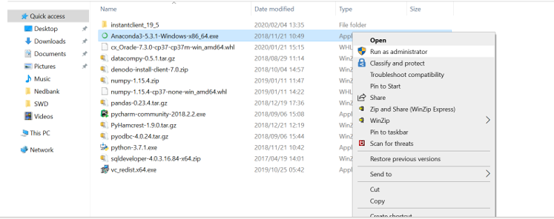

Click on **Run as Administrator**

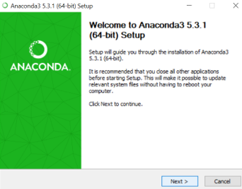

Select **Next**

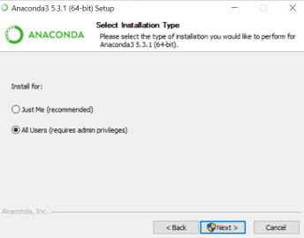

select **All Users** then **Next**

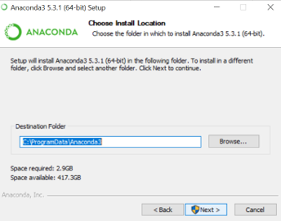

Select **Next**

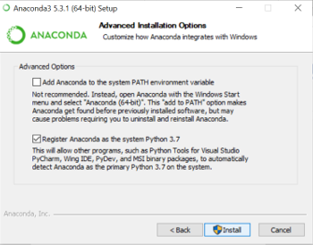

Select “Add Anaconda to the system PATH environment variable” and select **Install**

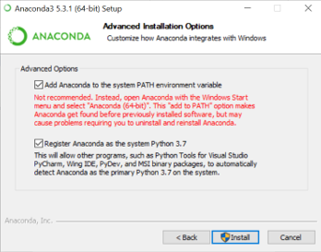

Wait until installation is complete – this process might take more 10-30

mins to complete

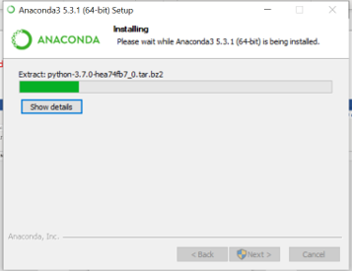

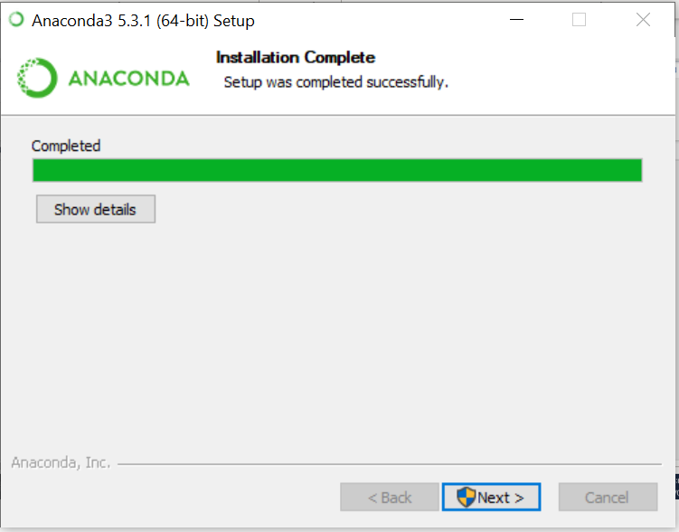

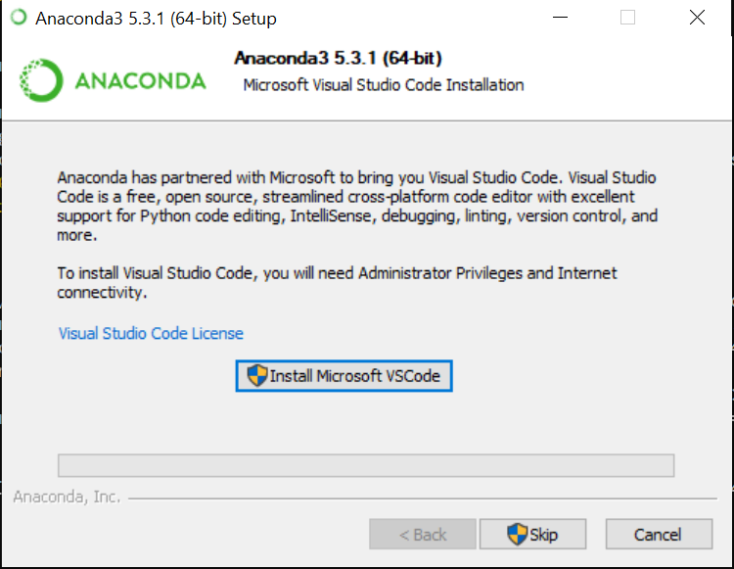

Click Install Microsoft VSCode( but make sure you are connected to internet when selecting this option)

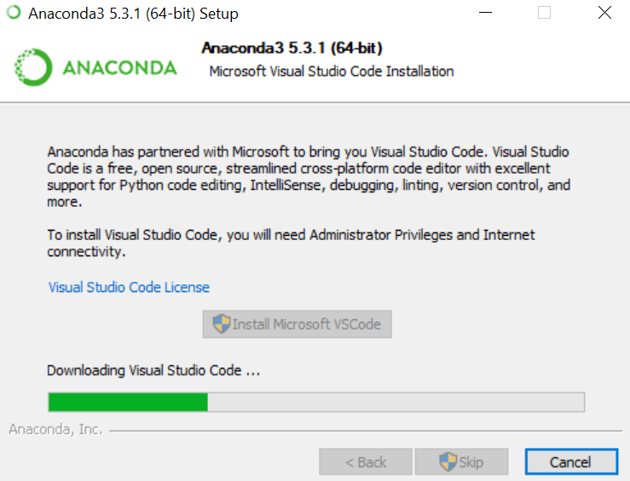

1. Run Anaconda CMD prompt as administrator and install below python packages listed from table below **starting** with (1-3) in order as there is dependencies. From 4, ordering is not important. These packages will be installed directly from internet, so make sure you are connected to internet

|  |  |
| --- | --- |
| **Package** | **Command to run on command prompt** |
| **1.Numpy** | pip install numpy==1.15.4 |
| **2.PyHamcrest** | pip install pyhamcrest==1.9.0 |
| **3.Pandas** | pip install pandas==0.23.4 |
| 4.Datacompy | pip install datacompy==0.5.1 |
| 5.Pyodbc | pip install pyodbc==4.0.24 |

On Anaconda command prompt run above commands for each package installation (as you will be installing from internet) e.g type **pip install numpy==1.15.4**

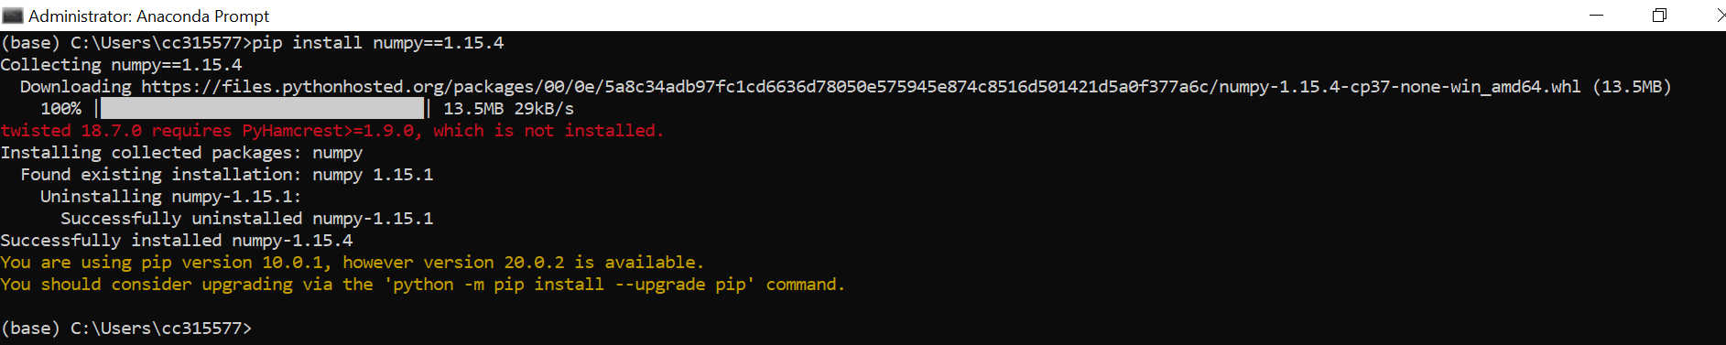

Do the rest for the rest of the packages 2-4 above, ensure that each is installed successfully

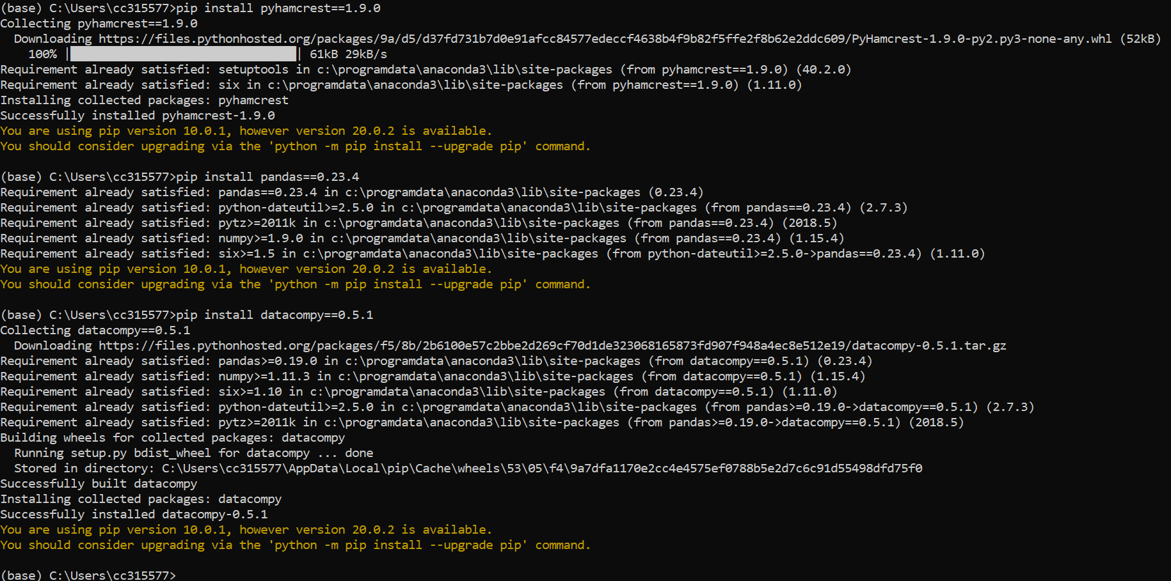

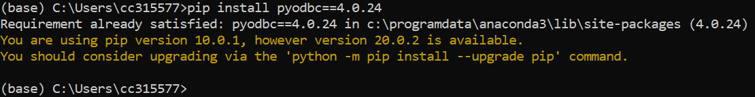

1. Open cmd prompt and go to location where your softwares located.

Install cx_oracle allowing python to connect to oracle database by typing following command “pip install cx_Oracle-7.3.0-cp37-cp37m-win_amd64.whl”

1. Install Microsoft visual C++ 2015 by double clicking on file vc_redist.x64.exe

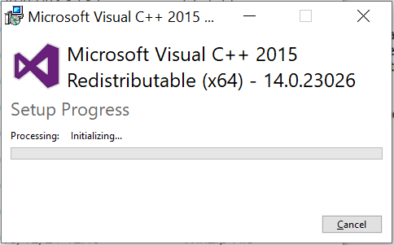 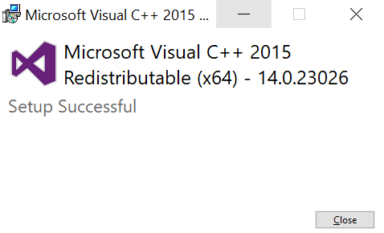

1. Install Aginity for DashDB - database:

Install ibm driver by double clicking on file ibm_data_server_driver_package_win64.exe

Note: It takes time to install, so be patient

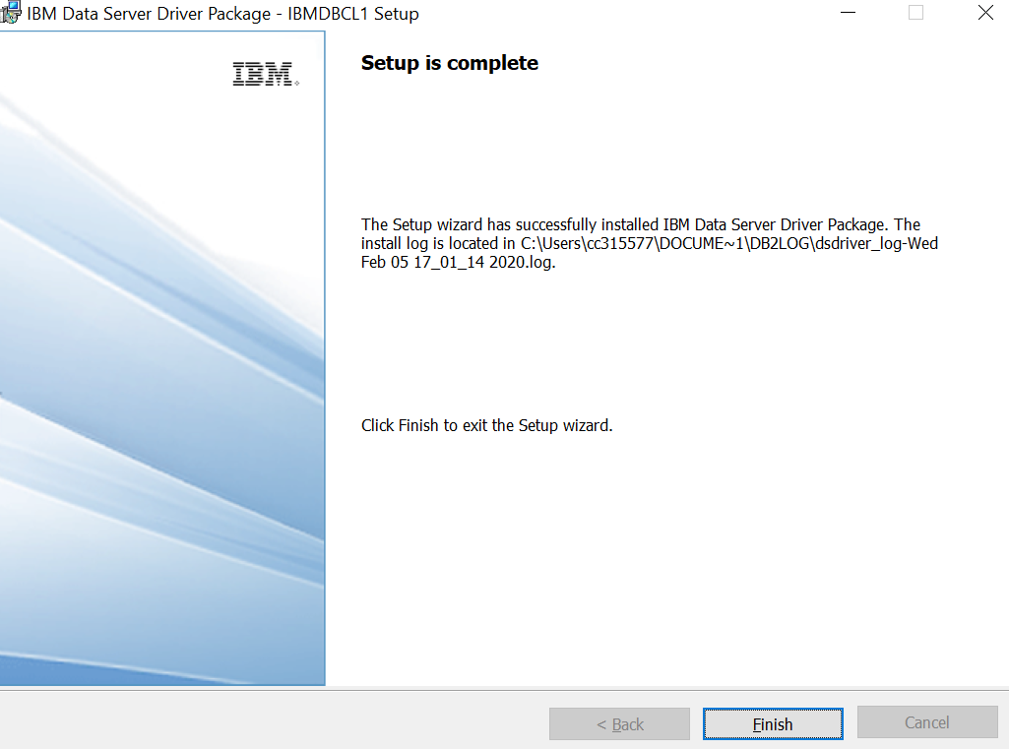

Install Aginity by running as an administrator, right click and run as an administrator

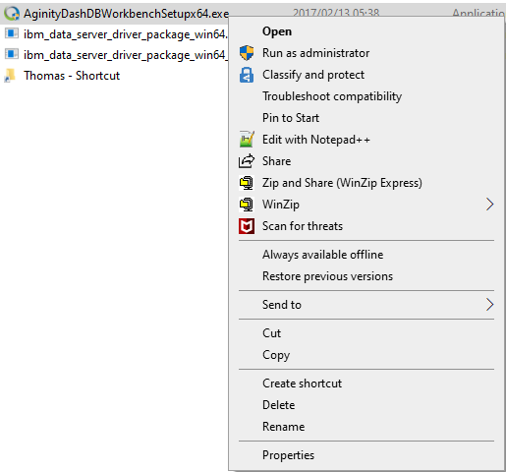

Click run run as administrator

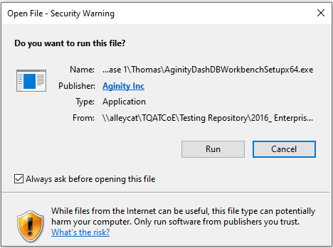

Click run

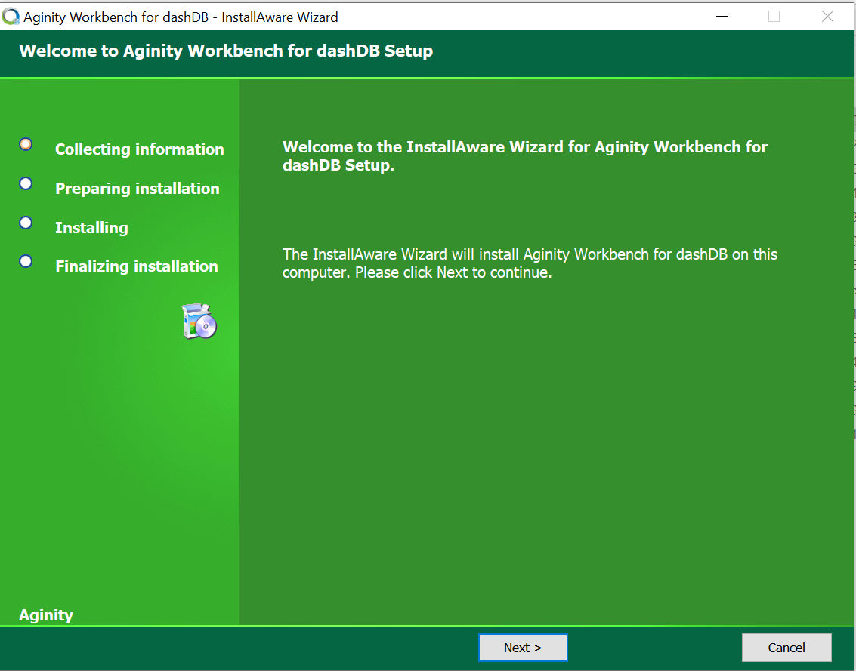

Select Next

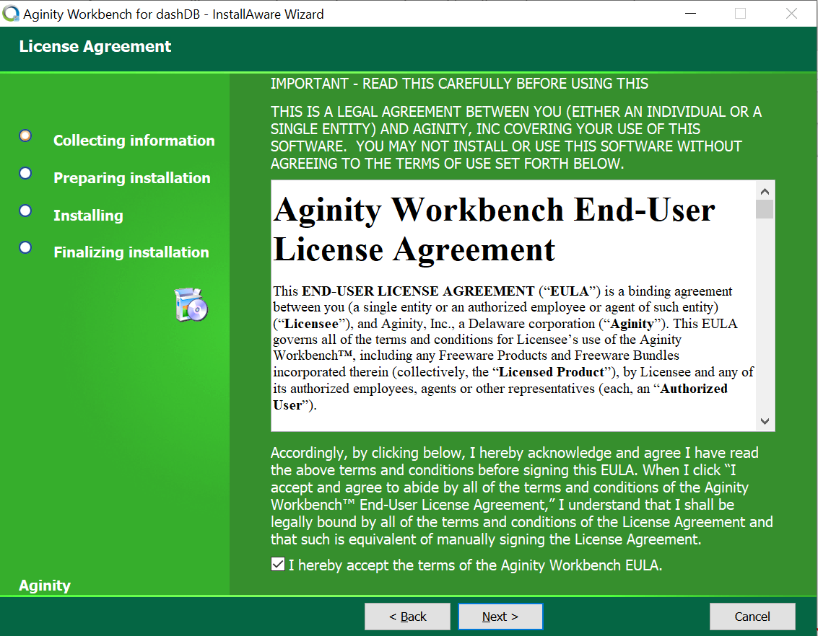

Agree and Next

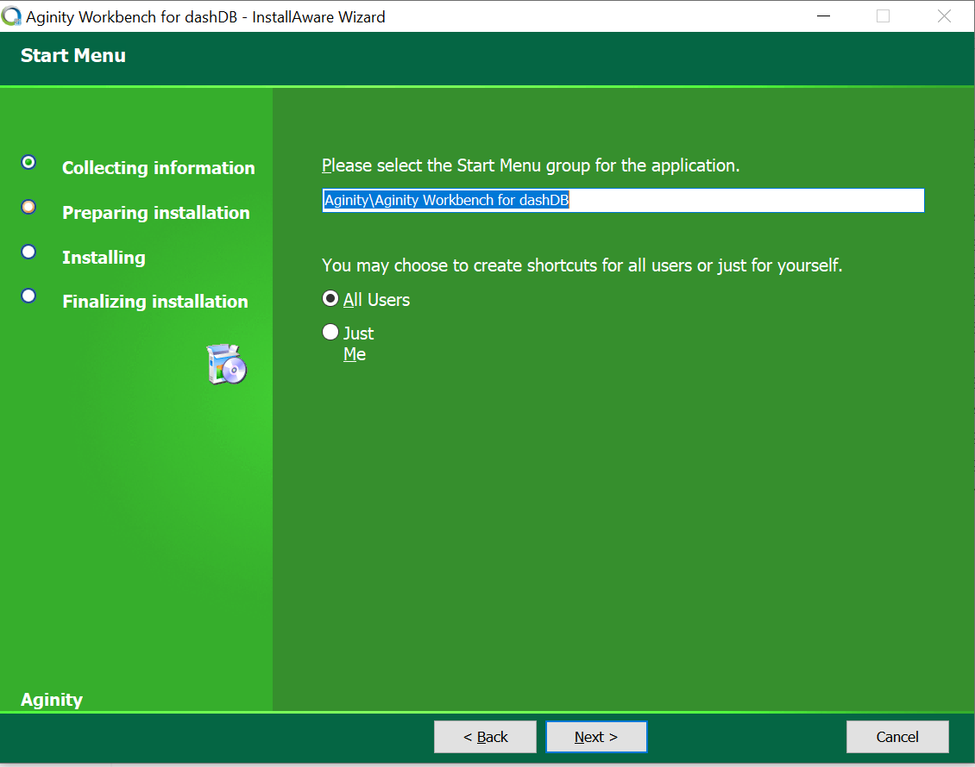

Click Next

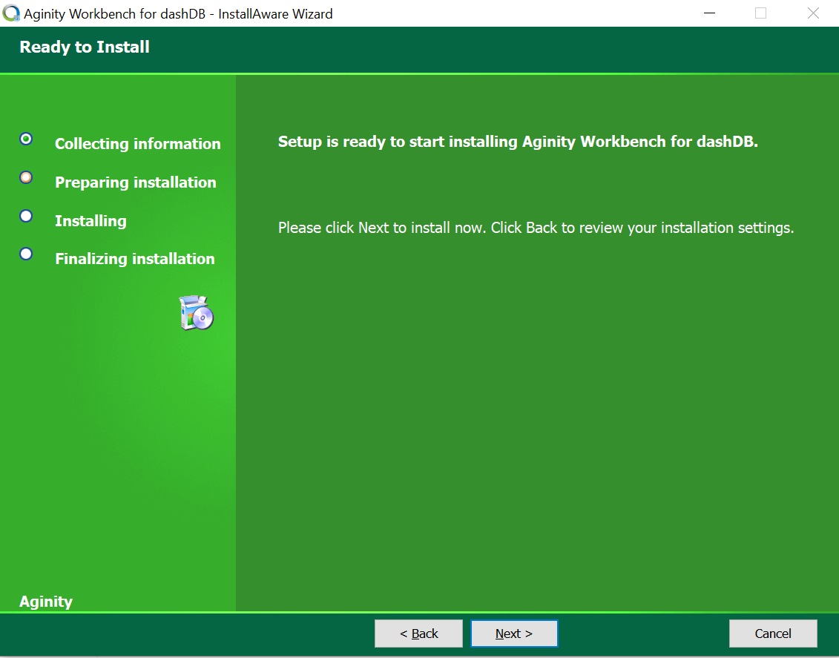

Click Next

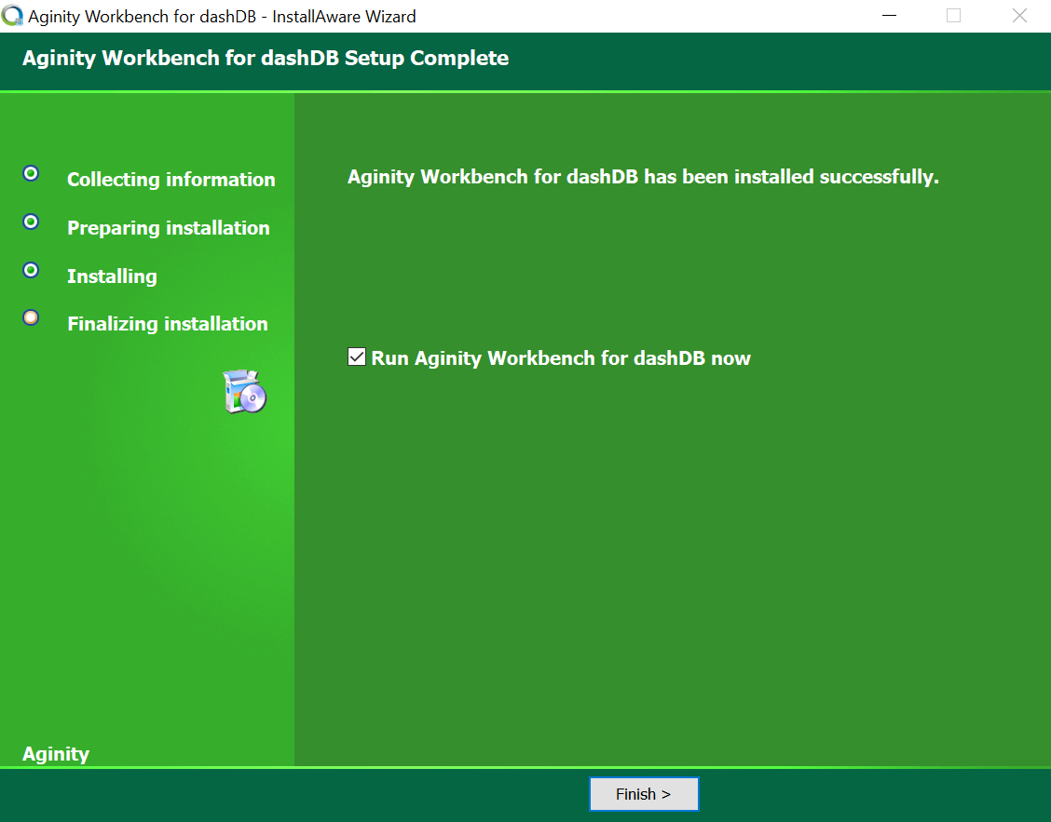

Click Finish

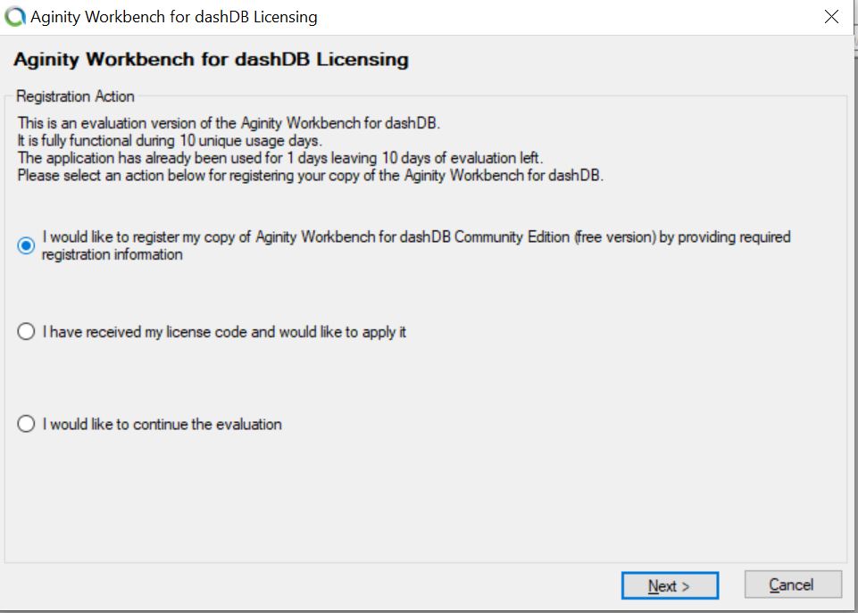

Select option “I would like to register” and select next

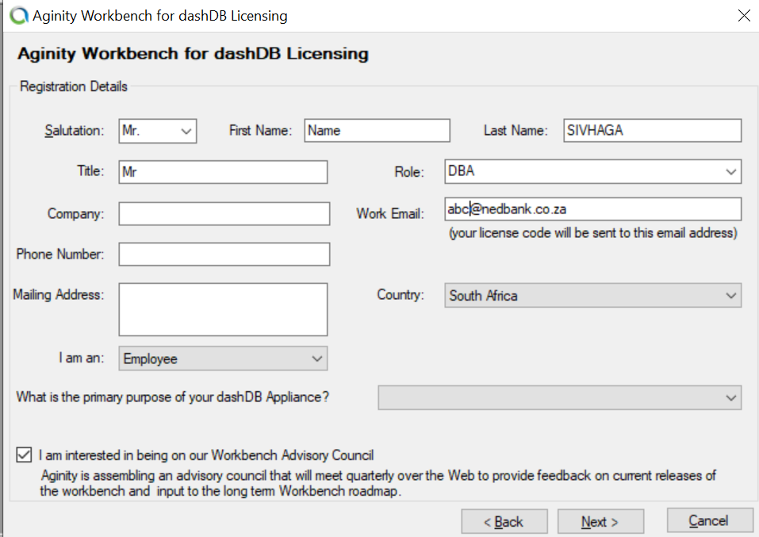

Fill in all details most importantly email address where licence will be provided

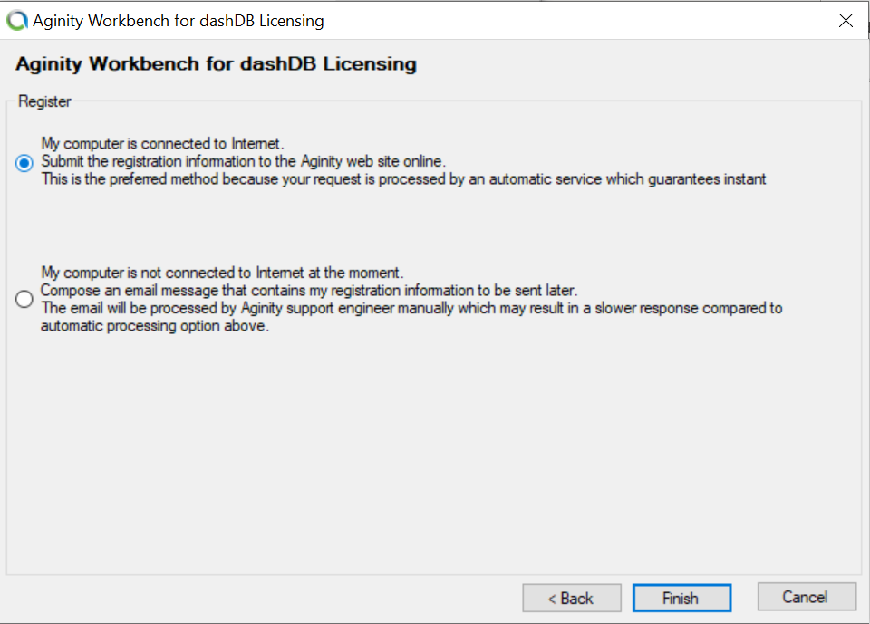

Make sure you are internet connected when you click Finish

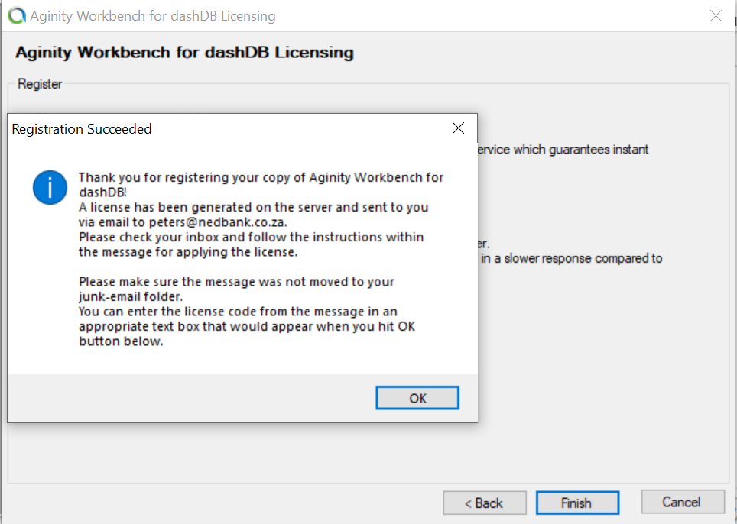

Click ok and finish

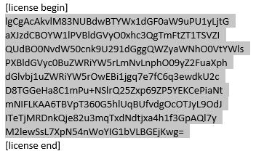

Check your email and copy licence and paste it per instruction